CS 255 System Design Document Template

UML Diagrams

UML Use Case Diagram
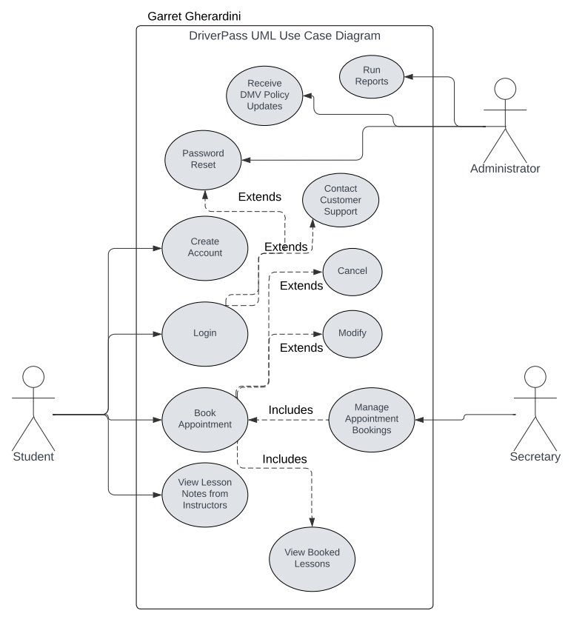

UML Activity Diagrams

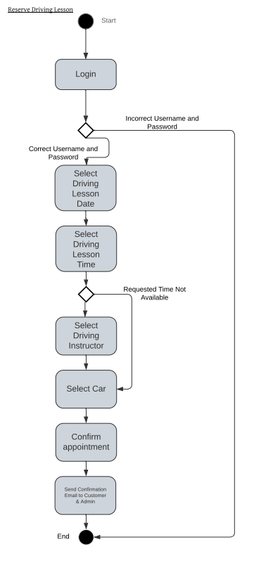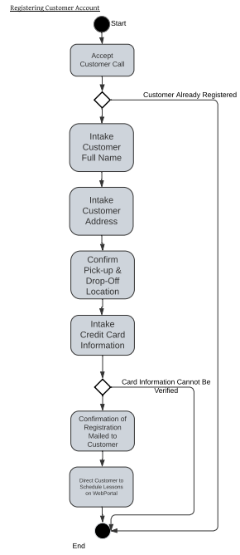

UML Sequence Diagram
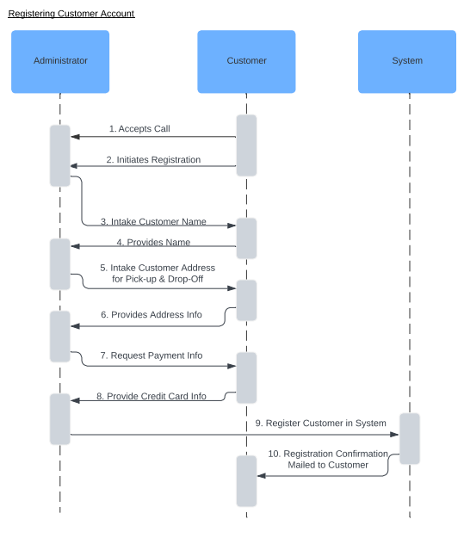

UML Class Diagram
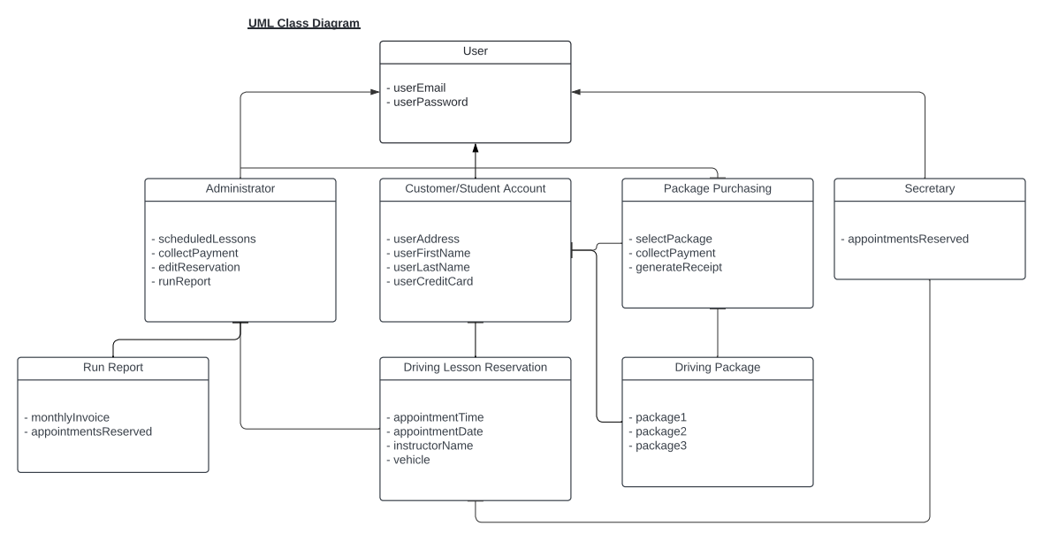

Technical Requirements
With this being a smaller business with potential room for expansion, it is recommended to utilize a cloud-based server for its cost-effective components and scalability. Computers should be provided for all administrative members to utilize the system, preferably installed with a Windows operating system. The utilization of an automated back-up system to maintain sensitive data such as customer and administrative information along with the implementation of security software to prevent any viruses will be required. Reliable internet connection is necessary for all administrative members to receive the most up to date changes in schedules, reservations, or policies submitted by the DMV. Access to DriverPass’s web-portal should be available on the most commonly used operating systems such as MacOS, Windows, iOS, and Android devices to reach a large number of customers.

